ITP 125 – Homework 03

Deadline

1 minute before the next class.

Objective

More Python. Yays!

Procedure

1. Goto <http://www.codecademy.com/tracks/python>.

Remember to carefully read the lesson on the left.   
  
**Important:** think about what you are doing, and don’t just follow blindly.

1. Do lessons the following lessons:

*Lists & Dictionaries*

*Python Lists and Dictionaries*

***A Day at the Supermarket***

*Lists and Functions*

*Lists and Functions*

***Battleship!***

*Loops*

*Loops*

***Practice Makes Perfect***

The lessons in bold will be the code that you will be submitting for a grade.

When you finish you should see something like this on bottom of the screen:



1. Before you can submit the lab, you will need to copy to code into a text editor like Notepad (Windows) or TextEdit (OSX). This next screenshot is the code that you need to copy from

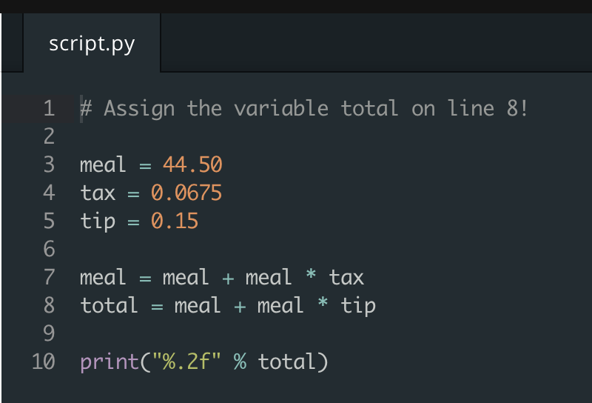

**The only code that you will need to submit is from lessons “A Day at the Supermarket”, “Battleship!”, and “Practice Makes Perfect”**

1. After you have copied the code, paste it into a text editor so it looks something like this:  
     
   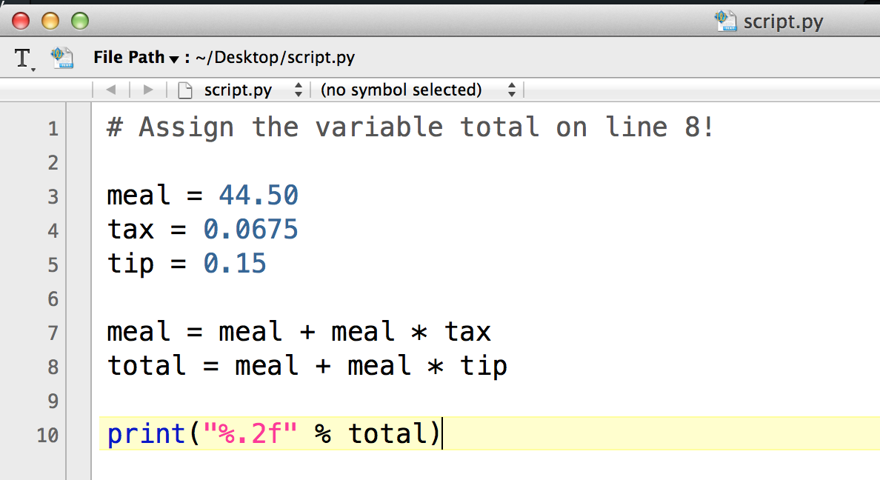

Save the file and name it as the following:

A Day at the Supermarket” 🡪 hw03a.py

Battleship! 🡪 hw03b.py

Practice Makes Perfect 🡪 how03c.py

You will be submitting all three files for a grade.

Submission

After you are done with answering the questions, name the file **hw03a.py, hw03b.py, and hw03c.py** then encrypt the file using **7zip or Keka**, and. Upload the file to your **itp125 folder** on the web hosting.

Set the password to be **nomorepython**

Make sure you can see the file by publicly accessing the URL using any web browser of your choosing.

Refer to lab 1 if you are having any issues.